Walk to School Day is an event that encourages walking, health, and safety and is celebrated internationally. In Pennsylvania, Walk to School Day is celebrated to build support for creating Safe Routes to School (SRTS). Walk to School Day may look a little different this year due to the effects of the COVID-19 pandemic, however there are still plenty of ways for your school to participate in this exciting event.
With the increase in technological supports during this time, there has been a shift in how we interact with one another; video calls, connecting via video chat, etc. One way to participate in a virtual Walk to School Day would be via Google Maps. Google Maps allows families to map out different walking routes in their area. Having your students create a walking map with their families is a great way to keep the classroom connected for this national event.

Step 1
www.Google.com/maps
On a desktop, enter your school’s address to see how far it is from your home, this will help you decide how long to make your walking path. After measuring the distance, decide how long you would like to make your family’s walk, it could be lesser, equal, or greater distance.
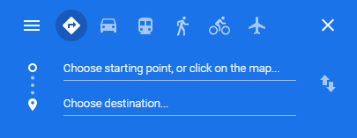

Step 2
Type in your home address, looking at your home on the map, right click your location and select “measure distance”, this will allow you to custom create your own path and find out its distance.
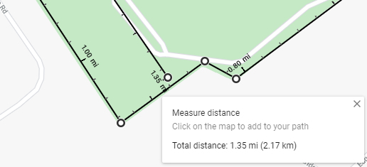

Step 3
Go walk! Gather your family and spend time together outside on Walk to School Day!

For more information on Walk to School Day, please visit the website
https://prowellness.childrens.pennstatehealth.org/school/programs/healthy-champions/healthy-champions-welcome/walk-to-school-day/

