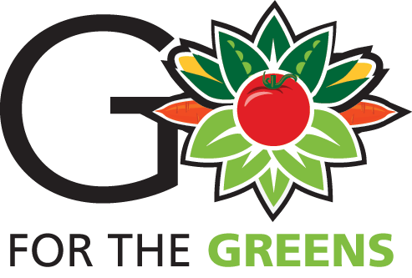
Go for the Greens promotes green veggies as good food and good fun! Schools and community organizations celebrate this event with taste-testing’s and other fun activities to open young minds and taste buds to the greatness of greens! This event emphasizes incorporating veggies as part of healthy meals with a focus on kids’ lunches and family dinner. The CDC states that just 1 in 10 Americans eats enough fruit and vegetables! Veggies should take up the majority of our meal portion.
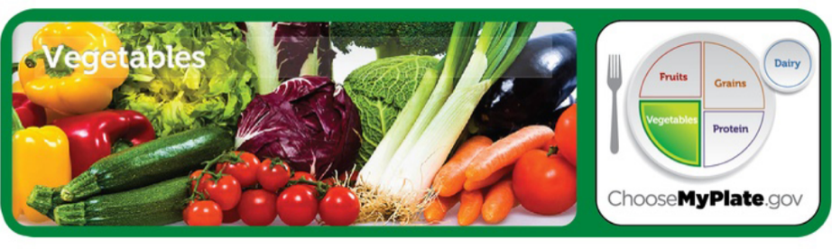
www.ChoseMyPlate.gov is great resources for all things nutrition! There are recipes and toolkits to educate and inform on health and diet.
A great way to engage children and families is to create a garden for fresh vegetables. Variety on your plate is a healthy way of making sure you get the nutrients you need. Just think of the rainbow of colors you could grow! View the Grow the Rainbow infographic.
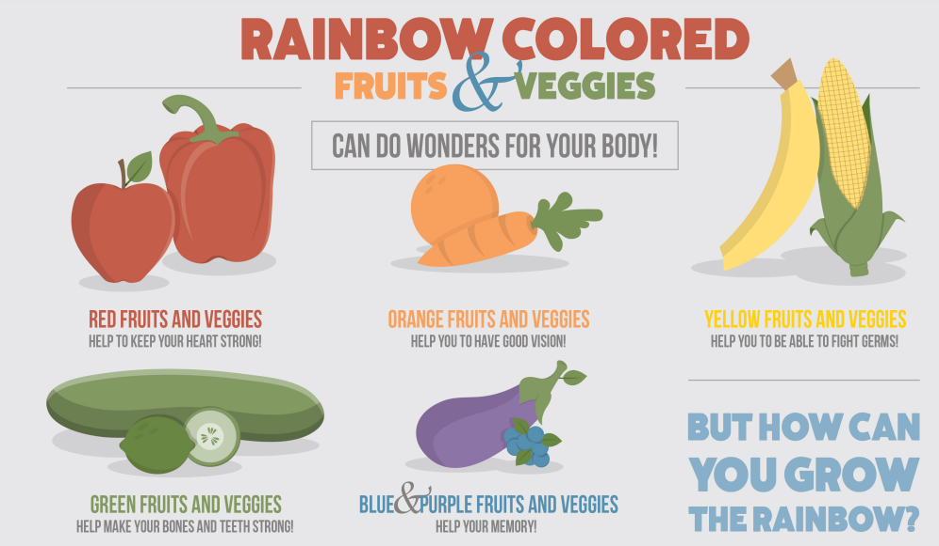

Smaller seeds can grow in pots, like peanuts, herbs, or tomatoes!
Bigger plants like watermelon or cucumbers can be grown in your backyard!
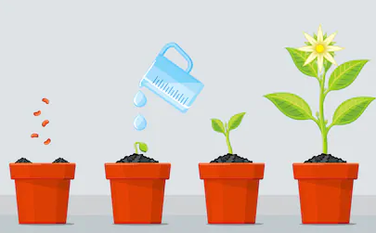
Check the website for information on your zone and best time to plant your seeds!

Raise your taste buds activity
Have students compete against one another virtually by taking photos of them trying a new vegetable or fruit each day. The vegetable does not need to be raw. Some of the best ways to enjoy vegetables is by cooking with them. Ask students to write down each new vegetable/fruit they tried and report back to the class on their favorite item!
Encourage students to shy away from the traditional items, such as lettuce and strawberries, by encouraging them to try avocado, zucchini, or even pineapple!
List of Vegetables: A-Z
List of Fruits: A-Z
For fun, try rewarding the student with the most new items tried a variety of seeds to plant at their favorite items at home!

