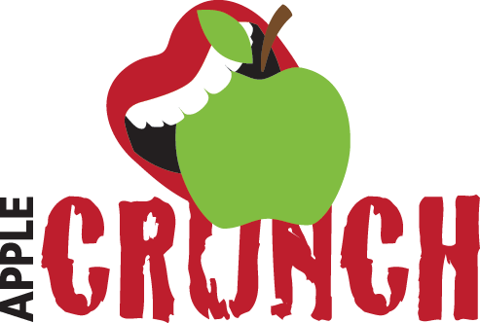

How to select the perfect apple for any occasion!
Share this video with students in October to show how they can select the perfect apple. Whether using an apple for baking or eating as a healthy snack, each apple has its own great benefits.
https://www.youtube.com/watch?v=v66RXOxPO6E#action=share

Pinterest ideas!
We have a board on our PRO Wellness Pinterest page with a variety of apple recipes, worksheets, activates, and artwork. Take a look

