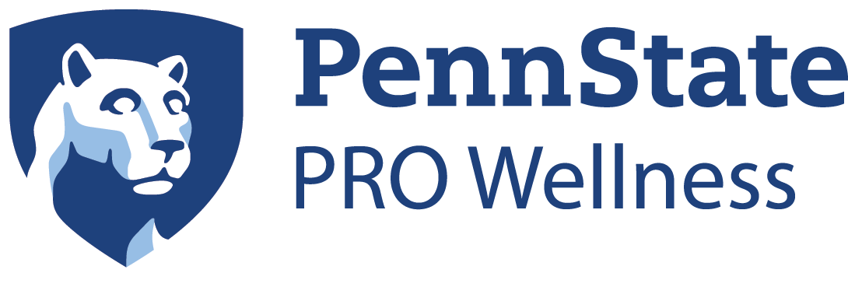

2020/2021 Healthy Champion Miscellaneous Virtual Resources
The below resources are available for teachers to share with students / families on ways they can remain healthy while doing virtual learning.

Nutrition
- How to cooking videos
  - How to Choose Apples
  - How to Blanch Vegetables
  - 12 Free Online Cooking Classes
  - 12 Chef Taught Online Classes
- GIANT resources
  - Rainbow of Fruits and Veggies
  - Build a Better Snack

Physical Activity
- Kohl’s Cares Activities
  - Aerobic Activities
  - Anaerobic Activities
  - Bone-Strengthening Activities
  - Cognitive Activities
  - Muscle-Strengthening Activites

Mental Health
- Be Mindful infographic
- Getting a Good Night’s Sleep infographic
- Mindfulness Journal
- Teen Health: Mental Health information video

Virtual Trips from Your Living Room
- Here’s a Massive List of Museums, Zoos, and Theme Parks Offering Virtual Tours
- 8 Stunning Virtual Garden Tours Around the World
- Experience Kennedy Space Center Visitor Complex with Space Visor
- Experience Disney Parks Around the World with these Virtual Rides

FREE TEACHING PLATFORMS
- Flipgrid
  - Flipgrid is a simple, free, and accessible video discussion experience for PreK to PhD educators, learners and families. Create a Topic and engage your community...together!

- Kahoot
  - Kahoot! is a game-based learning platform that brings engagement and fun to 1+ billion players every year at school, at work, and at home. Sign up for free!

- Quizizz
  - Free gamified quizzes for every subject to play in class and at home. Pick an existing quiz or create your own for review, formative assessment, and more.

