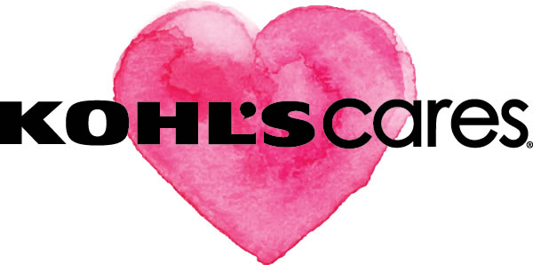
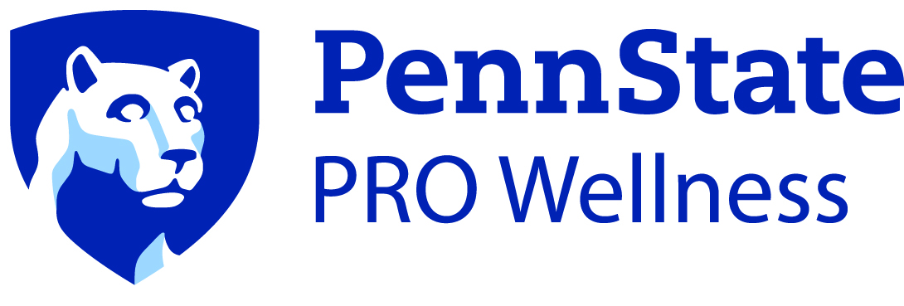

Kohl’s Circle of Wellness Publicity Toolkit

Introduction
The Kohl’s Circle of Wellness program is evidence-based, established, and well-tested to be implemented throughout multiple Pennsylvania school districts. Penn State PRO Wellness will guide schools during the academic year to identify needs, develop an action plan, and implement sustainable mental and physical health, programming.
In partnership with Penn State PRO Wellness, Kohl’s is pleased to provide Kohl’s Circle of Wellness funding to your school.
To maximize your school’s exposure and create a broader understanding of the mental and physical health initiatives you are addressing, we encourage you to promote the program in as multiple ways. The enclosed toolkit provides you with publicity ideas and communication suggestions intended to guide you through this process.
If you speak with a member of the media, please contact us via email, as we would like to make sure your school is recognized and tracked for receiving media coverage and attention. Additionally, please send us copies of news releases, newsletter articles, promotional materials and newspaper articles that mention the Kohl’s Circle of Wellness program activities.
For all public relations and media relations needs, or for the use of Kohl’s Cares®, Circle of Wellness, PRO Wellness logos and other promotion materials, please contact:
Penn State PRO Wellness
717-531-1440, ext. 0
Funding was provided by the Kohl’s Cares® Hospital Program grants. This publication’s contents are solely the responsibility of the authors and do not necessarily represent the official views of Kohl’s Cares®.
PROwellness@pennstatehealth.psu.edu

Publicity Guidelines
- Please mention that the program your school/district is implementing is part of the “Kohl’s Circle of Wellness Program” and that “grants are delivered through Penn State PRO Wellness.”
- Please include an acknowledgement that “funding is provided by Kohl’s Cares®” in all press releases, newsletters, website mentions, brochures, annual reports and other promotional materials for this program.
- All media materials need to be reviewed by Kohl’s PR team via PRO Wellness. Please submit materials to PRO Wellness (PROwellness@pennstatehealth.psu.edu) and plan for at least one week for us to obtain approvals.
Text guidelines:
- Include an apostrophe and the registered trademark symbol in Kohl’s Cares®.
- Capitalize “PRO” in Penn State PRO Wellness.
Additional text that may be included:
- “Kohl’s Circle of Wellness program is a Penn State PRO Wellness initiative made possible by funding from Kohl’s Cares®. The grant funds are intended to assist school districts in establishing an action plan focused on mental health to ensure healthy lifestyles in Pennsylvania.”

- “The school-based goals of the program are to create a sustainable action plan focused on whole child wellness, specifically the intersection of mental and physical health. The long-term goal for the program is to create sustainable change within the schools. By establishing sustainable school practices that support healthy living, schools can help set the stage to ensure healthier lives for our next generation.”

- “The Whole School, Whole Community, Whole Child (WSCC) Framework is ‘student-centered and emphasizes the role of the community in supporting the school, the connections between health and academic achievement and the importance of evidence-based school policies and practices.’ The school will develop an action plan with the help of community resources, support and input. PRO Wellness will provide technical assistance to help the district determine wellness priorities and action plan implementation.”
- “Kohl’s is committed to inspiring and empowering families to lead fulfilled lives. Through partnerships with children’s hospitals across the country, they help address the needs of local communities to improve the lives of thousands of families every day. Kohl’s Cares® programs support community relationships through kids’ health and education, breast cancer awareness and green environmental solutions. Kohl’s Cares® is committed to giving back to local communities and supporting the causes that matter to you and your neighbors.”
- “Penn State PRO Wellness is committed to educating and inspiring youth and their families to eat well, engage in regular physical activity, and become champions for bringing healthy choices to life. Their approach of Prevention, Research and Outreach provides schools, communities and like-minded organizations with program development and implementation, assessment and evaluation, capacity building, technical assistance, collaborative partnerships, and access to proven wellness interventions.”

Publicity Ideas
By promoting the Kohl’s Circle of Wellness program your school will gain recognition as a wellness champion in the community. We suggest that you think about already existing activities or programs scheduled to take place throughout the school year and use them as an opportunity to announce this wellness program. Here are some publicity tips to utilize:
- Promote your program at a kick-off event, like an assembly or pep rally.
  - Please provide at least three weeks’ notice to PRO Wellness once an event date is confirmed. Dignitary or funding agency attendance may be arranged with sufficient notice and is dependent on scheduling.
- Announce your program at a meeting (i.e. school district meeting, PTO meeting, etc.)
- Publicize your program in newsletter publications, board meeting updates and on your website. Use the wellness content and artwork on our program portal page to supplement this information.
- Distribute a press release announcing your program, and contact local media to cover a story on the initiatives that will be implemented (see news release template on next page).
- Tell your story via social media (see “Social Media Toolkit” on page 6 for suggestions).

Template News Release
School/District Name Participates in Healthy Living Education Program
CITY, PA (DATE, 2019) – Kohl’s Cares® is partnering with Penn State PRO Wellness to provide School Name with funding and resources necessary to establish a sustainable action plan focused on whole child wellness. This is part of larger initiative among seven counties across central Pennsylvania to establish targeted efforts at the intersection of mental and physical health.
“There is growing awareness of how mental wellness affects overall physical health and well-being. With our strong history in nutrition, physical activity and obesity prevention, PRO Wellness is ideally positioned to assist schools in implementing school health initiatives to encourage and promote sustainable wellness change.” said Deepa L. Sekhar, M.D., executive director of PRO Wellness. “We are excited to support School Name and look forward to seeing new wellness initiatives and practices put into place.”
[Insert comment from superintendent or other wellness personnel at district.]
School wellness teams will develop an action plan focused on whole child wellness, and implement the action plan.
Insert District Program Specifics
About District Name
Insert District Boiler Plate
About Kohl’s Cares®
At Kohl's, we are all about families. Through partnerships with children’s hospitals across the country, we help address the needs of local communities to improve the lives of thousands of families every day.
Our local programs range from healthy development and safety to wellness and chronic disease management. All programs provide crucial education and resources to help families lead healthier and safer lifestyles.
About Penn State PRO Wellness
Penn State PRO Wellness is committed to educating and inspiring youth and their families to eat well, engage in regular physical activity, be mindful, and become champions for bringing healthy choices to life. Our approach of Prevention, Research and Outreach provides schools, communities and like-minded organizations with program development and implementation, assessment and evaluation, capacity building, technical assistance, collaborative partnerships, and access to evidence-based wellness interventions.
###

Flyer/Letter for Parents
While teachers and leaders in your district and schools will be implementing wellness activities aimed at promoting and implementing supportive mental health and physical health resources in schools, it’s just as important for parents to be aware of these practices. Helping parents understand the significance of this program and the opportunities being offered to the students will help them adapt these best practices and sustain healthy activities with their children at home. Below is a sample letter that can be used or adapted for a flyer.
Sample letter for districts or school buildings to distribute to parents:
Dear Parent:
I am excited to announce that (name of school/district) has been invited to participate in Kohl’s Circle of Wellness program, in collaboration with the Penn State PRO Wellness. Our district recognizes that schools play a critical role in promoting the health and safety of our students and helping them establish lifelong healthy behavior patterns. This program will help our school and our entire district to enhance wellness policies and practices in the area of whole child wellness, with lasting change for students today and in future years.
We encourage you to talk to your child about this program and find out what he/she is learning. Look for opportunities and announcements to get involved in this program. (Note here any events planned associated with the program – i.e., wellness council representation, kick-off events.)
We are excited to participate in this wellness program and wanted to share the news; we continue to work every day to make (name of school) a better place.
Sincerely,
(name of principal)
(name of school)

Social Media Toolkit
Social media posts are a great way to engage your school community in the promotion of healthy behaviors and to inform them of events and programs occurring in your school or community, including your participation in the Kohl’s Circle of Wellness program. The information below describes resources available for you when creating social media posts.
- Using #KohlsCares #CircleofWellness Hashtags.
  - Hashtags (#) are used as a way of gathering content from multiple social media posters into one area.
  - To have your posts added to this gathered content, simply add #KohlsCares and #CircleofWellness somewhere in your posts.
  - Please tag Penn State PRO Wellness in your posts where appropriate.
    - #PROwellness
    - @PSH_PROwellness
  - To view the other posts of these hashtags either search them or follow these links:
    - Facebook: (Hint: you need to be logged into Facebook for these links to work!)
      - #KohlsCares: https://www.facebook.com/search/top/?q=%23KohlsCares%20
      - #circleofwellness: https://www.facebook.com/search/top/?q=%23circleofwellness&epa=SEARCH_BOX
    - Twitter:
      - #KohlsCares: https://twitter.com/search?q=%23KohlsCares&src=typd&lang=en
      - #circleofwellness:
      - https://twitter.com/search?q=%23circleofwellness&src=typed_query
- Circle of Wellness resources are available at med.psu.edu/PROwellness. Visit the Kohl's Cares webpage to access program material.
  - Planning and implementing templates with accompanying social media post examples are available to your school for promoting healthy behaviors to students and families. Visit the Healthy Champions webpage within med.psu.edu/PROwellness. Use the password, HEALTHYCHAMPS1920, to access the promotional toolkit and social media content.
  - Social media post examples: Please visit the Kohl’s Circle of Wellness Program page (information above) to access prewritten social media posts.
  - Artwork: This artwork can be used to promote your program via social media, parent or school newsletters, or on your school website. For use of Kohl’s Cares® or PRO Wellness logos and other promotion materials, please contact:
Penn State PRO Wellness
717-531-1440, ext. 0
prowellness@pennstatehealth.psu.edu

CDC. (2019, May 29). Whole School, Whole Community, Whole Child (WSCC) | Healthy Schools | CDC. Retrieved from https://www.cdc.gov/healthyschools/wscc/index.htm

